weights = [1.5, 0.3, 1.0]

1 run...

<tqdm.auto.tqdm object at 0x7fc647b96790>

<tqdm.auto.tqdm object at 0x7fc6610e8b90>

training 1 epoch...

155.88551712036133 seconds used......

1 training finished! average train loss: 0.5737879316471769

evaluating...

Confusion matrix, without normalization

[[ 845 46 131]

[2535 2726 146]

[1496 128 9141]]

Normalized confusion matrix

[[0.82681018 0.04500978 0.12818004]

[0.46883669 0.50416127 0.02700203]

[0.13896888 0.01189039 0.84914073]]

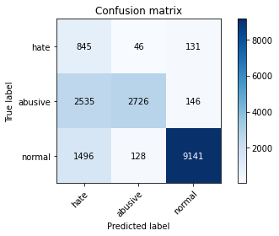

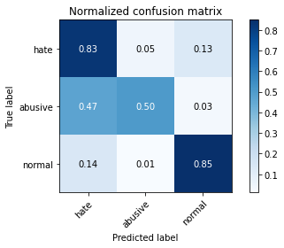

precision recall f1-score support

hate 0.17 0.83 0.29 1022

abusive 0.94 0.50 0.66 5407

normal 0.97 0.85 0.91 10765

accuracy 0.74 17194

macro avg 0.69 0.73 0.62 17194

weighted avg 0.91 0.74 0.79 17194

average eval_loss: 0.4834918277728003, accuracy: 0.7393276724438758

training 2 epoch...

155.1794810295105 seconds used......

2 training finished! average train loss: 0.41126817622922074

evaluating...

Confusion matrix, without normalization

[[ 796 79 147]

[1782 3489 136]

[1328 188 9249]]

Normalized confusion matrix

[[0.77886497 0.07729941 0.14383562]

[0.32957278 0.64527464 0.02515258]

[0.12336275 0.017464 0.85917325]]

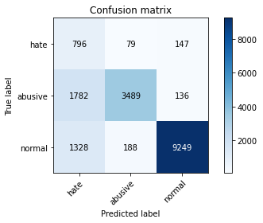

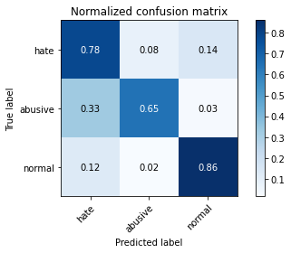

precision recall f1-score support

hate 0.20 0.78 0.32 1022

abusive 0.93 0.65 0.76 5407

normal 0.97 0.86 0.91 10765

accuracy 0.79 17194

macro avg 0.70 0.76 0.67 17194

weighted avg 0.91 0.79 0.83 17194

average eval_loss: 0.46221445220154384, accuracy: 0.7871350471094568

training 3 epoch...

155.1778359413147 seconds used......

3 training finished! average train loss: 0.2900418484453154

evaluating...

Confusion matrix, without normalization

[[ 864 53 105]

[2513 2749 145]

[2119 150 8496]]

Normalized confusion matrix

[[0.84540117 0.0518591 0.10273973]

[0.46476789 0.50841502 0.02681709]

[0.19684162 0.01393405 0.78922434]]

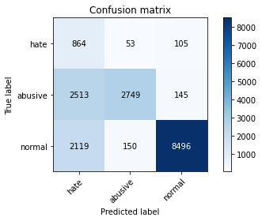

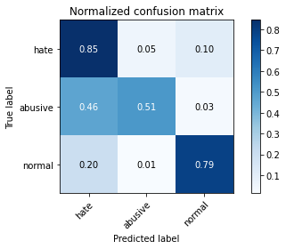

precision recall f1-score support

hate 0.16 0.85 0.27 1022

abusive 0.93 0.51 0.66 5407

normal 0.97 0.79 0.87 10765

accuracy 0.70 17194

macro avg 0.69 0.71 0.60 17194

weighted avg 0.91 0.70 0.77 17194

average eval_loss: 0.6232590114307958, accuracy: 0.7042572990578109

training 4 epoch...

155.1691336631775 seconds used......

4 training finished! average train loss: 0.18842963788565878

evaluating...

Confusion matrix, without normalization

[[ 823 92 107]

[1659 3610 138]

[2163 229 8373]]

Normalized confusion matrix

[[0.80528376 0.09001957 0.10469667]

[0.30682449 0.66765304 0.02552247]

[0.20092894 0.02127264 0.77779842]]

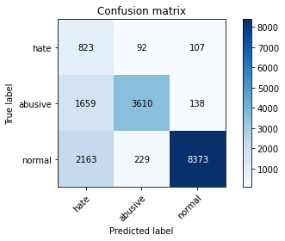

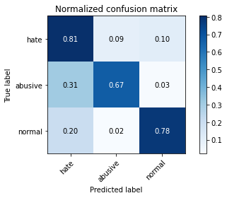

precision recall f1-score support

hate 0.18 0.81 0.29 1022

abusive 0.92 0.67 0.77 5407

normal 0.97 0.78 0.86 10765

accuracy 0.74 17194

macro avg 0.69 0.75 0.64 17194

weighted avg 0.91 0.74 0.80 17194

average eval_loss: 0.8153292569743339, accuracy: 0.7447946958241247

training 5 epoch...

155.11149621009827 seconds used......

5 training finished! average train loss: 0.14290145975506063

evaluating...

Confusion matrix, without normalization

[[ 778 113 131]

[1651 3599 157]

[1702 268 8795]]

Normalized confusion matrix

[[0.76125245 0.11056751 0.12818004]

[0.30534492 0.66561864 0.02903643]

[0.15810497 0.02489549 0.81699954]]

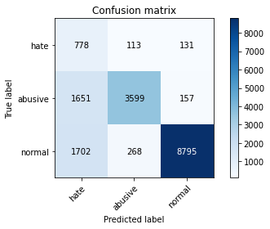

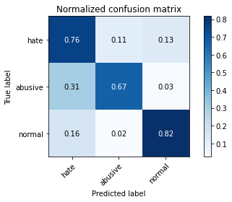

precision recall f1-score support

hate 0.19 0.76 0.30 1022

abusive 0.90 0.67 0.77 5407

normal 0.97 0.82 0.89 10765

accuracy 0.77 17194

macro avg 0.69 0.75 0.65 17194

weighted avg 0.90 0.77 0.81 17194

average eval_loss: 0.7952729583457979, accuracy: 0.766081191113179

2 run...

training 1 epoch...

155.04594564437866 seconds used......

1 training finished! average train loss: 0.5824730119438796

evaluating...

Confusion matrix, without normalization

[[ 771 93 158]

[1490 3740 177]

[1238 199 9328]]

Normalized confusion matrix

[[0.75440313 0.09099804 0.15459883]

[0.27556871 0.69169595 0.03273534]

[0.11500232 0.01848583 0.86651184]]

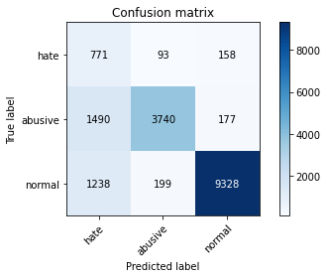

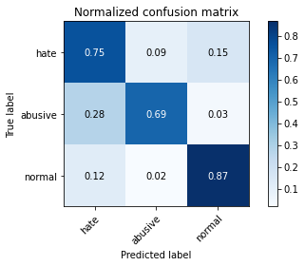

precision recall f1-score support

hate 0.22 0.75 0.34 1022

abusive 0.93 0.69 0.79 5407

normal 0.97 0.87 0.91 10765

accuracy 0.80 17194

macro avg 0.70 0.77 0.68 17194

weighted avg 0.91 0.80 0.84 17194

average eval_loss: 0.44319422820279764, accuracy: 0.8048737931836687

training 2 epoch...

155.2209722995758 seconds used......

2 training finished! average train loss: 0.4117881714725871

evaluating...

Confusion matrix, without normalization

[[ 808 92 122]

[1559 3717 131]

[1715 198 8852]]

Normalized confusion matrix

[[0.79060665 0.09001957 0.11937378]

[0.28832994 0.6874422 0.02422785]

[0.15931259 0.01839294 0.82229447]]

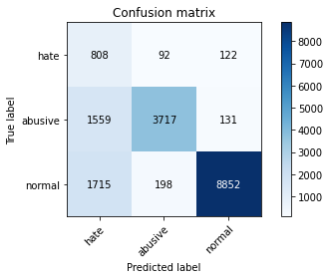

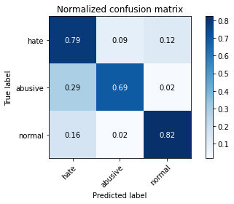

precision recall f1-score support

hate 0.20 0.79 0.32 1022

abusive 0.93 0.69 0.79 5407

normal 0.97 0.82 0.89 10765

accuracy 0.78 17194

macro avg 0.70 0.77 0.67 17194

weighted avg 0.91 0.78 0.82 17194

average eval_loss: 0.5451591784004555, accuracy: 0.7780039548679772

training 3 epoch...

155.25530314445496 seconds used......

3 training finished! average train loss: 0.29057459746809094

evaluating...

Confusion matrix, without normalization

[[ 790 96 136]

[1545 3725 137]

[1523 230 9012]]

Normalized confusion matrix

[[0.77299413 0.09393346 0.13307241]

[0.28574071 0.68892177 0.02533753]

[0.14147701 0.02136554 0.83715745]]

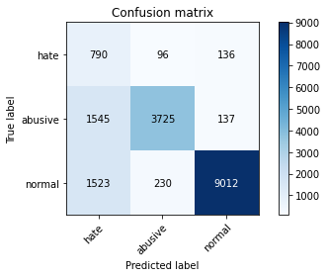

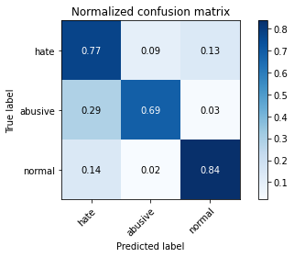

precision recall f1-score support

hate 0.20 0.77 0.32 1022

abusive 0.92 0.69 0.79 5407

normal 0.97 0.84 0.90 10765

accuracy 0.79 17194

macro avg 0.70 0.77 0.67 17194

weighted avg 0.91 0.79 0.83 17194

average eval_loss: 0.5949518893087327, accuracy: 0.7867279283470978

training 4 epoch...

155.11101913452148 seconds used......

4 training finished! average train loss: 0.19873014371631914

evaluating...

Confusion matrix, without normalization

[[ 798 103 121]

[1635 3625 147]

[1929 262 8574]]

Normalized confusion matrix

[[0.78082192 0.10078278 0.1183953 ]

[0.3023858 0.67042722 0.02718698]

[0.17919183 0.02433813 0.79647004]]

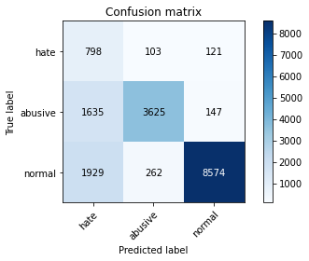

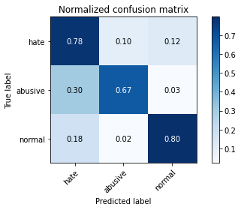

precision recall f1-score support

hate 0.18 0.78 0.30 1022

abusive 0.91 0.67 0.77 5407

normal 0.97 0.80 0.87 10765

accuracy 0.76 17194

macro avg 0.69 0.75 0.65 17194

weighted avg 0.90 0.76 0.81 17194

average eval_loss: 0.7868849658298978, accuracy: 0.7559032220542049

training 5 epoch...

155.27963066101074 seconds used......

5 training finished! average train loss: 0.14024052437832138

evaluating...

Confusion matrix, without normalization

[[ 802 106 114]

[1707 3569 131]

[1767 276 8722]]

Normalized confusion matrix

[[0.78473581 0.1037182 0.11154599]

[0.31570187 0.66007028 0.02422785]

[0.16414306 0.02563864 0.8102183 ]]

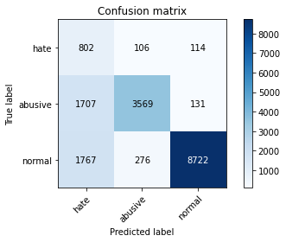

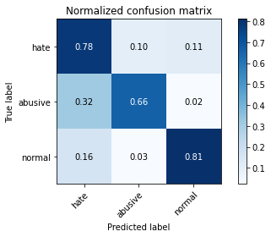

precision recall f1-score support

hate 0.19 0.78 0.30 1022

abusive 0.90 0.66 0.76 5407

normal 0.97 0.81 0.88 10765

accuracy 0.76 17194

macro avg 0.69 0.75 0.65 17194

weighted avg 0.90 0.76 0.81 17194

average eval_loss: 0.7661529467202897, accuracy: 0.7614865650808421

3 run...

training 1 epoch...

155.16521859169006 seconds used......

1 training finished! average train loss: 0.590487975702867

evaluating...

Confusion matrix, without normalization

[[ 812 93 117]

[1461 3819 127]

[1600 232 8933]]

Normalized confusion matrix

[[0.79452055 0.09099804 0.11448141]

[0.27020529 0.70630664 0.02348807]

[0.14862982 0.02155132 0.82981886]]

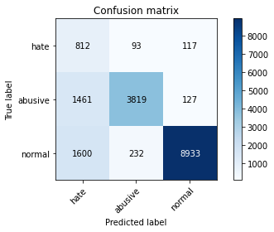

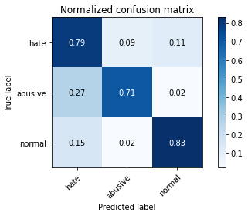

precision recall f1-score support

hate 0.21 0.79 0.33 1022

abusive 0.92 0.71 0.80 5407

normal 0.97 0.83 0.90 10765

accuracy 0.79 17194

macro avg 0.70 0.78 0.68 17194

weighted avg 0.91 0.79 0.83 17194

average eval_loss: 0.5151215621205263, accuracy: 0.7888798418052809

training 2 epoch...

155.18692588806152 seconds used......

2 training finished! average train loss: 0.4165622043690348

evaluating...

Confusion matrix, without normalization

[[ 795 88 139]

[1507 3732 168]

[1351 202 9212]]

Normalized confusion matrix

[[0.7778865 0.08610568 0.13600783]

[0.27871278 0.69021639 0.03107083]

[0.1254993 0.01876451 0.85573618]]

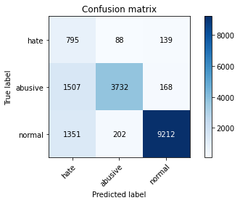

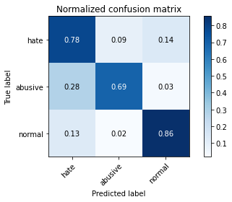

precision recall f1-score support

hate 0.22 0.78 0.34 1022

abusive 0.93 0.69 0.79 5407

normal 0.97 0.86 0.91 10765

accuracy 0.80 17194

macro avg 0.70 0.77 0.68 17194

weighted avg 0.91 0.80 0.84 17194

average eval_loss: 0.4595755772015383, accuracy: 0.799057810864255

training 3 epoch...

155.17652702331543 seconds used......

3 training finished! average train loss: 0.29243418517150405

evaluating...

Confusion matrix, without normalization

[[ 729 94 199]

[1494 3697 216]

[1059 237 9469]]

Normalized confusion matrix

[[0.71330724 0.09197652 0.19471624]

[0.27630849 0.6837433 0.03994822]

[0.09837436 0.02201579 0.87960985]]

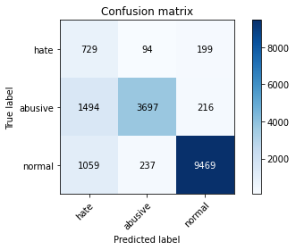

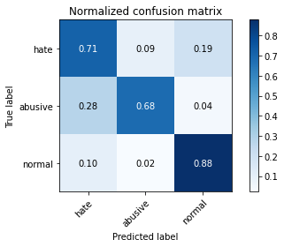

precision recall f1-score support

hate 0.22 0.71 0.34 1022

abusive 0.92 0.68 0.78 5407

normal 0.96 0.88 0.92 10765

accuracy 0.81 17194

macro avg 0.70 0.76 0.68 17194

weighted avg 0.90 0.81 0.84 17194

average eval_loss: 0.4459644150422063, accuracy: 0.8081307432825404

training 4 epoch...

155.0348641872406 seconds used......

4 training finished! average train loss: 0.19035629811854382

evaluating...

Confusion matrix, without normalization

[[ 796 109 117]

[1515 3741 151]

[1869 282 8614]]

Normalized confusion matrix

[[0.77886497 0.10665362 0.11448141]

[0.28019234 0.6918809 0.02792676]

[0.17361821 0.02619601 0.80018579]]

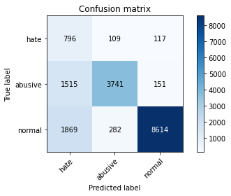

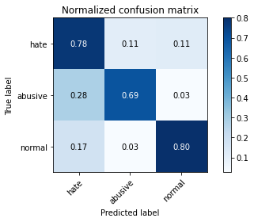

precision recall f1-score support

hate 0.19 0.78 0.31 1022

abusive 0.91 0.69 0.78 5407

normal 0.97 0.80 0.88 10765

accuracy 0.76 17194

macro avg 0.69 0.76 0.66 17194

weighted avg 0.90 0.76 0.81 17194

average eval_loss: 0.7121228213833515, accuracy: 0.7648598348261021

training 5 epoch...

155.26784992218018 seconds used......

5 training finished! average train loss: 0.13350869070646051

evaluating...

Confusion matrix, without normalization

[[ 774 125 123]

[1411 3861 135]

[1661 352 8752]]

Normalized confusion matrix

[[0.75733855 0.1223092 0.12035225]

[0.26095802 0.71407435 0.02496763]

[0.15429633 0.03269856 0.81300511]]

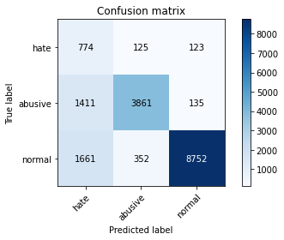

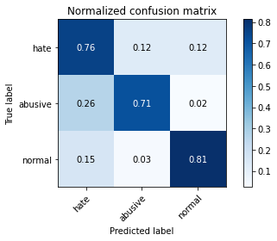

precision recall f1-score support

hate 0.20 0.76 0.32 1022

abusive 0.89 0.71 0.79 5407

normal 0.97 0.81 0.89 10765

accuracy 0.78 17194

macro avg 0.69 0.76 0.67 17194

weighted avg 0.90 0.78 0.82 17194

average eval_loss: 0.7466780375775903, accuracy: 0.7785855530999186

4 run...

training 1 epoch...

155.09233164787292 seconds used......

1 training finished! average train loss: 0.5816570299069984

evaluating...

Confusion matrix, without normalization

[[ 836 69 117]

[1828 3440 139]

[1634 190 8941]]

Normalized confusion matrix

[[0.81800391 0.06751468 0.11448141]

[0.33808027 0.63621232 0.02570742]

[0.1517882 0.01764979 0.83056201]]

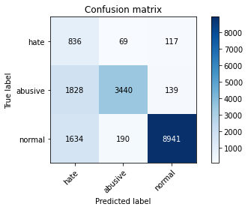

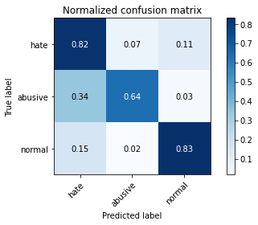

precision recall f1-score support

hate 0.19 0.82 0.31 1022

abusive 0.93 0.64 0.76 5407

normal 0.97 0.83 0.90 10765

accuracy 0.77 17194

macro avg 0.70 0.76 0.66 17194

weighted avg 0.91 0.77 0.82 17194

average eval_loss: 0.5201081728692665, accuracy: 0.7686983831569152

training 2 epoch...

155.2926959991455 seconds used......

2 training finished! average train loss: 0.4134772633692212

evaluating...

Confusion matrix, without normalization

[[ 869 61 92]

[2187 3108 112]

[2204 169 8392]]

Normalized confusion matrix

[[0.85029354 0.05968689 0.09001957]

[0.40447568 0.57481043 0.02071389]

[0.20473758 0.01569902 0.7795634 ]]

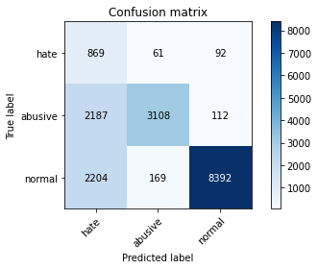

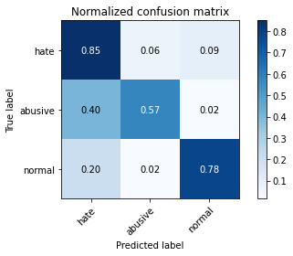

precision recall f1-score support

hate 0.17 0.85 0.28 1022

abusive 0.93 0.57 0.71 5407

normal 0.98 0.78 0.87 10765

accuracy 0.72 17194

macro avg 0.69 0.73 0.62 17194

weighted avg 0.91 0.72 0.78 17194

average eval_loss: 0.6242804577184278, accuracy: 0.7193788530882866

training 3 epoch...

155.27728271484375 seconds used......

3 training finished! average train loss: 0.28721994163287684

evaluating...

Confusion matrix, without normalization

[[ 805 64 153]

[2043 3176 188]

[1447 184 9134]]

Normalized confusion matrix

[[0.78767123 0.06262231 0.14970646]

[0.37784354 0.58738672 0.03476974]

[0.13441709 0.01709243 0.84849048]]

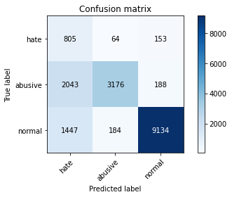

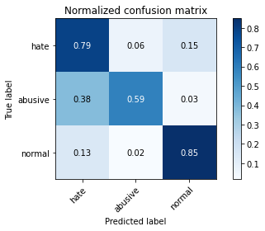

precision recall f1-score support

hate 0.19 0.79 0.30 1022

abusive 0.93 0.59 0.72 5407

normal 0.96 0.85 0.90 10765

accuracy 0.76 17194

macro avg 0.69 0.74 0.64 17194

weighted avg 0.91 0.76 0.81 17194

average eval_loss: 0.5145294909473769, accuracy: 0.7627660811911132

training 4 epoch...

155.11976289749146 seconds used......

4 training finished! average train loss: 0.19005333050732284

evaluating...

Confusion matrix, without normalization

[[ 822 96 104]

[1783 3441 183]

[2416 248 8101]]

Normalized confusion matrix

[[0.80430528 0.09393346 0.10176125]

[0.32975772 0.63639726 0.03384502]

[0.22443103 0.02303762 0.75253135]]

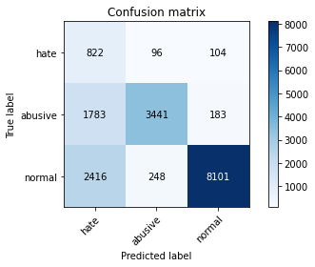

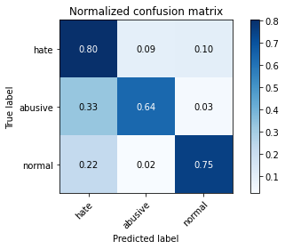

precision recall f1-score support

hate 0.16 0.80 0.27 1022

abusive 0.91 0.64 0.75 5407

normal 0.97 0.75 0.85 10765

accuracy 0.72 17194

macro avg 0.68 0.73 0.62 17194

weighted avg 0.90 0.72 0.78 17194

average eval_loss: 0.9421091258612483, accuracy: 0.7190880539723159

training 5 epoch...

155.4145336151123 seconds used......

5 training finished! average train loss: 0.14485404298390614

evaluating...

Confusion matrix, without normalization

[[ 767 117 138]

[1367 3863 177]

[1597 241 8927]]

Normalized confusion matrix

[[0.75048924 0.11448141 0.13502935]

[0.25282042 0.71444424 0.03273534]

[0.14835114 0.02238737 0.8292615 ]]

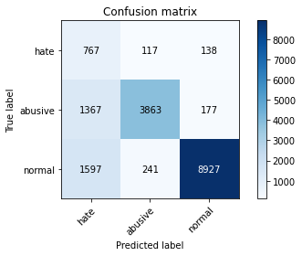

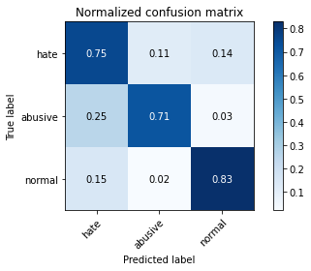

precision recall f1-score support

hate 0.21 0.75 0.32 1022

abusive 0.92 0.71 0.80 5407

normal 0.97 0.83 0.89 10765

accuracy 0.79 17194

macro avg 0.70 0.76 0.67 17194

weighted avg 0.90 0.79 0.83 17194

average eval_loss: 0.7625984669771305, accuracy: 0.7884727230429219

5 run...

training 1 epoch...

155.0899534225464 seconds used......

1 training finished! average train loss: 0.5890061823697446

evaluating...

Confusion matrix, without normalization

[[ 867 41 114]

[2964 2314 129]

[1850 104 8811]]

Normalized confusion matrix

[[0.84833659 0.04011742 0.11154599]

[0.54817829 0.42796375 0.02385796]

[0.17185323 0.00966094 0.81848583]]

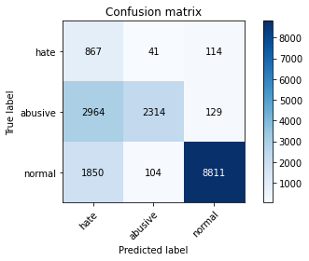

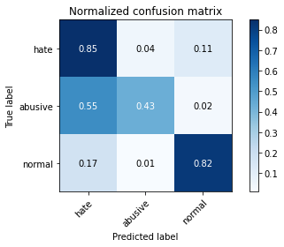

precision recall f1-score support

hate 0.15 0.85 0.26 1022

abusive 0.94 0.43 0.59 5407

normal 0.97 0.82 0.89 10765

accuracy 0.70 17194

macro avg 0.69 0.70 0.58 17194

weighted avg 0.91 0.70 0.76 17194

average eval_loss: 0.561788482669481, accuracy: 0.6974525997440968

training 2 epoch...

155.31560158729553 seconds used......

2 training finished! average train loss: 0.41857685288309243

evaluating...

Confusion matrix, without normalization

[[ 824 91 107]

[1577 3680 150]

[2022 218 8525]]

Normalized confusion matrix

[[0.80626223 0.0890411 0.10469667]

[0.29165896 0.68059922 0.02774182]

[0.18783093 0.02025081 0.79191825]]

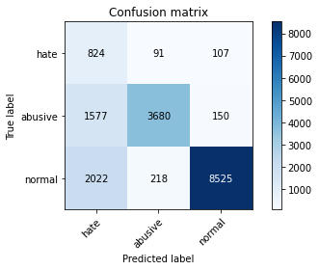

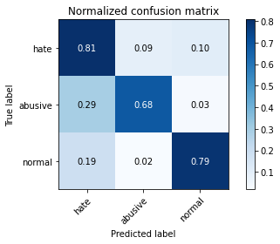

precision recall f1-score support

hate 0.19 0.81 0.30 1022

abusive 0.92 0.68 0.78 5407

normal 0.97 0.79 0.87 10765

accuracy 0.76 17194

macro avg 0.69 0.76 0.65 17194

weighted avg 0.91 0.76 0.81 17194

average eval_loss: 0.5618469820812692, accuracy: 0.7577643363964174

training 3 epoch...

155.39227652549744 seconds used......

3 training finished! average train loss: 0.3026798291649022

evaluating...

Confusion matrix, without normalization

[[ 821 88 113]

[1572 3728 107]

[1935 229 8601]]

Normalized confusion matrix

[[0.80332681 0.08610568 0.11056751]

[0.29073423 0.6894766 0.01978916]

[0.17974919 0.02127264 0.79897817]]

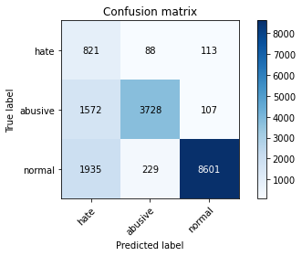

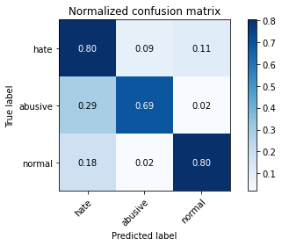

precision recall f1-score support

hate 0.19 0.80 0.31 1022

abusive 0.92 0.69 0.79 5407

normal 0.98 0.80 0.88 10765

accuracy 0.76 17194

macro avg 0.70 0.76 0.66 17194

weighted avg 0.91 0.76 0.82 17194

average eval_loss: 0.6409369387945464, accuracy: 0.764801675002908

training 4 epoch...

155.3167233467102 seconds used......

4 training finished! average train loss: 0.20036896925764347

evaluating...

Confusion matrix, without normalization

[[ 737 131 154]

[1152 4057 198]

[1552 259 8954]]

Normalized confusion matrix

[[0.72113503 0.12818004 0.15068493]

[0.21305715 0.75032365 0.0366192 ]

[0.14417092 0.02405945 0.83176962]]

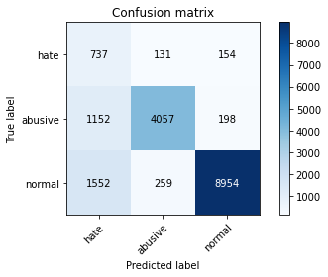

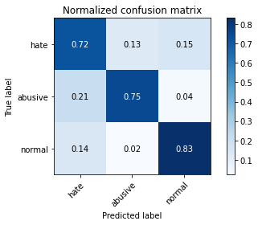

precision recall f1-score support

hate 0.21 0.72 0.33 1022

abusive 0.91 0.75 0.82 5407

normal 0.96 0.83 0.89 10765

accuracy 0.80 17194

macro avg 0.70 0.77 0.68 17194

weighted avg 0.90 0.80 0.84 17194

average eval_loss: 0.6690406058026954, accuracy: 0.7995812492730022

training 5 epoch...

155.34163403511047 seconds used......

5 training finished! average train loss: 0.1399387869107249

evaluating...

Confusion matrix, without normalization

[[ 759 129 134]

[1415 3853 139]

[2018 345 8402]]

Normalized confusion matrix

[[0.74266145 0.12622309 0.13111546]

[0.2616978 0.71259478 0.02570742]

[0.18745936 0.0320483 0.78049234]]

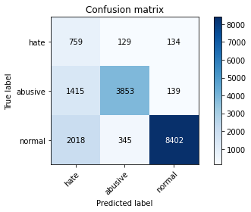

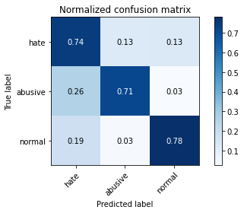

precision recall f1-score support

hate 0.18 0.74 0.29 1022

abusive 0.89 0.71 0.79 5407

normal 0.97 0.78 0.86 10765

accuracy 0.76 17194

macro avg 0.68 0.75 0.65 17194

weighted avg 0.90 0.76 0.81 17194

average eval_loss: 0.9113785494118929, accuracy: 0.7568919390485053